ABN 72 132 932 855

professional photographic laboratory

Service Price Booklet

1st April 2026

“Communication and understanding are as critical as the
skills required to print your images.”

Frontier Digital Pty. Ltd.

Shop 2, 645 Sherwood Road P.O. Box 266

Sherwood Qld 4075 Sherwood Qld 4075

Telephone (07) 3376.6450

info@frontierdigital.com.au

www.frontierdigital.com.au



General Information & Scanning/Printing

Specifications
01/04/2026
Printing:

- Media Accepted: IBM Format CD, DVD, SM & CF Cards, USB Sticks

- File Specifications: * RGB Colour,
* No Layers, Paths or Alpha Channels
* JPEG, TIFF (Not LZW), or BMP (24 bit colour)

- Resolution: 300dpi at Print Size (see price list for available print sizes)

- Colour Space Used: SRGB (machine will convert if different)
Ideally all files should be saved as SRGB to avoid any colour shift/difference

- Labelling: Please place in folders with Size Name (e.g. “5x7”, 6”x4”)

- Cropping: The Frontier System automatically crops about 2mm off each edge of every sized print that is outputted.
This cannot be avoided, so please allow for this.

- Unable to print: PSD, CMYK, Grayscale or unflattened files

Scanning:

- File Sizes Available: 7MB, 14MB, 25MB, 40MB
(Note: File size indicated is in Bitmap form)

- Formats Accepted: 35mm ONLY

- Film Types Accepted: Negative (Colour or B&W C41), and developed transparency.

Packaging & Freight:

- Brisbane Metro Area: $20.00 Couriers Please
$30.00 Express Post 5kg
$20.00 Express Post 3kg
$18.00 Express Post 500g

- Outside Metro Area: #30.00 Express Post 5Kg
$20.00 Express Post 3kg
$18.00 Express Post 500g

File Transfer Protocol & ICC Profiling
01/04/2026

FTP
(File Transfer Protocol)
Saves you time and money

You can now experience FTP for free.

The only requirement is FTP software which can be down loaded free of charge. After you install the software we will allow you access to our server by using your individual user name and password.

It’s that easy!!!

- ADSL or Broadband is required
- We DO NOT charge you to use FTP
- You have full control over uploads/downloads
- No maximum time out issues with our server
- Save time
- Save freight
- Save money
- Distance is now not an issue

File management:
- Jpeg files only, saved at level 8 Baseline jpeg
- Place files in folders with print size named (eg. 5x7, 8x12 etc.)
- If more than one copy is required, name the folder (eg. 5x7 2off, 8x12 5off etc.)
- Normal turnaround time applies for files sent via FTP

Recommended Free FTP software site
- Coffee cup (for PC users)
- Filezilla (for PC or Mac users)

ICC Profiling
(International Color Consortium)

Frontier Digital is ICC Profiled. This means that you have our printers profile to work with. This enables you to proof your image on your monitor and see how our printers will print it.

.

Please contact us for more information as well as our ICC Profile files.

Photoshop Color Settings
01/04/2026

[Type a quote from the document or the summary of an interesting point. You can position the text box anywhere in the document. Use the Drawing Tools tab to change the formatting of the pull quote text box.]
[Type a quote from the document or the summary of an interesting point. You can position the text box anywhere in the document. Use the Drawing Tools tab to change the formatting of the pull quote text box.]

Please contact Frank for additional information if required
Lustre (Fuji) Printing
01/04/2026

All prints are required to be saved as JPEG images @ 300 dpi file with the image sized as required
(G) = Gloss Finish (Optional)

LUSTRE

Print Size

Inch Cm

3.5x5 9x13cm .60
(G) 4x4 10x10cm .60
(G) 4x6 10x15cm .70
5x5 13x13cm $1.20
5x7 13x18cm $1.30
5x7.5 13x18.5cm $1.40
(G) 6x6 15x15cm $1.40
(G) 6x8 15x20cm $1.50
(G) 6x9 15x22cm $1.70
8x8 20x20cm $2.20
8x10 20x25cm $3.00
8x12 20x30cm $4.00
10x10 25x25cm $5.00
10x12 25x30cm $5.50
10x14 25x35.5cm $6.00
10x15 25x37cm $7.00
11x11 27.5x27.5cm $9.00
11x14 27.5x35cm $10.00
11x16 27.5x40cm $12.00
12x12 30.5x30.5cm $12.00
12x14 30.5x35cm $13.00
12x16 30.5x40cm $14.00
12x18 30.5x46cm $15.00

All prices quoted include GST and are subject to change without notice.

Lustre Ink Jet (Epson) Printing
01/04/2026

These are printed on Inkjet Paper (Epson Premium Lustre)

16x20 40x50cm $18.00
16x24 40x60cm $20.00
20x20 50x50cm $20.00
20x24 50x60cm $25.00
20x30 50x75cm $30.00

The cost of 24” wide ink jet is priced at $1.50 per inch.

The cost of 36” wide ink jet is priced at $1.95 per inch

The cost of 44” wide ink jet is priced at $2.75 per inch.

24” Width 36” Width 44” Width

24”x24” - $36.00 36”x36” - $70.00 44”x40” - $110.00
24”x30” - $45.00 36”x40” - $78.00 44”x50” - $137.50
24”x36” - $54.00 36”x50” - $97.50 44”x60” - $165.00
24”x40” - $60.00 36”x60” - $117.00 44”x70” - $192.50
24”x50” - $75.00 36”x70” - $136.50 44”x80” - $220.00
24”x60” - $90.00 36”x80” - $156.00
24”x70” - $105.00
24”x80” - $120.00

PLEASE NOTE: This is only a sample of print sizes available.
We can print any size using either 24”, 36” or 44” wide paper.

PLEASE ALLOW 24 HOURS IN LAB FOR THIS SERVICE
All prices quoted include GST and are subject to change without notice.
Cotton Rag Paper (310gsm)

01/04/2026

Canson Photographique Cotton Rag 310GSM Paper

Print Size
Inch Cm
8x8 20x20cm $5.75
8x10 20x25cm $12.00
8x12 20x30cm $12.00
10x10 25x25cm $12.00
10x15 25x37cm $15.00
11x14 27.5x35cm $17.00
11x16 27.5x40cm $19.00
12x12 30.5x30.5cm $15.00
12x14 30.5x35cm $18.00
12x16 30.5x40cm $19.00
12x18 30.5x46cm $19.00

16x20 40x50cm $40.00
16x24 40x60cm $45.00
20x20 50x50cm $46.00
20x24 50x60cm $55.00
20x30 50x75cm $69.00

Priced using 24” wide paper at $3.00 per inch length
36” wide paper at $3.75 per inch length
44” wide paper at $4.50 per inch length

All prices quoted include GST and are subject to change without notice

Custom Framing
01/04/2026

Frontier Digital (Sherwood Rd Picture Framing) offers a professional custom framing services and we provide expert advice and recommendations on how best to frame your needs.

We have a wide selection of frame mouldings to choose from and with our expertise of over 25 years’ experience in custom framing, we can find a frame that best suits your piece of art. We use archival materials and acid-free matboards with multi glass choices.

Some of our framing services include
- Picture Framing
- Custom Framing
- Float Framing for Canvas Prints
- Canvas Stretching Service
- Jersey Framing
- Ready Made Frames

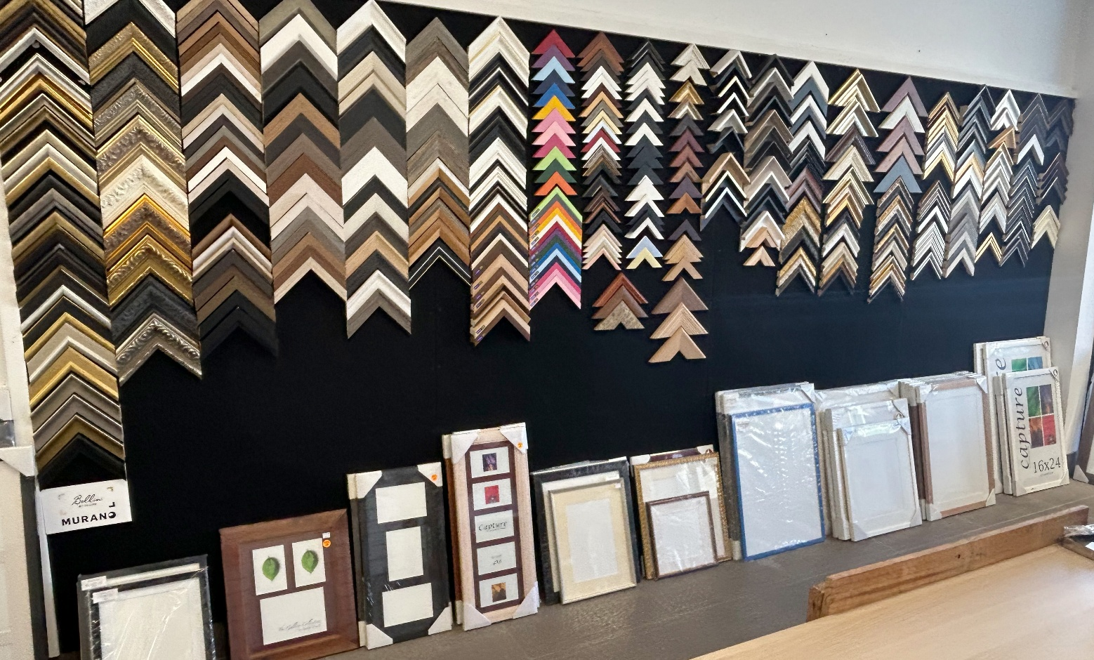

Museum Grade – Pre Cut Mats.
01/06/2026

Our pre-cut mats have a matboard backing, the same as the mat. We cut the aperture required from one side of the mat and fold the other side to give a stable backing for your prints.
These are available in off white and black only.

Matboard Size Print Size Price

Rectangle

16”x20” 12”x18”
11”x14” $14.95
10”x15”
10”x14”
A3

12”x16” 8”x12” $11.95
A4

11”x14” 8”x10” $9.95

8”x10” 6”x8” $8.95
5”x7”

6”x8” 4”x6” $5.95

Square
8”x8” 6”x6” $7.95

12”x12” 8”x8” $9.95

14”x14” 10”x10” $13.95

16”x16” 12”x12” $13.95

We can also custom cut.

All prices quoted include GST and are subject to change without notice

Canvas Printing

01/04/2026

All canvas prints are sprayed with a protective coating (PremierArt Eco Print Shield) designed specifically for water resistant ink jet media. Its advanced polymer technology will not crack under stretching and will never go brittle. Eco Print Shield protects all ink jet media from moisture, light, humidity, atmospheric contaminants, abrasion and fingerprints.
Eco Print Shield’s performance rating exceeds 100 years.

Canvas Printing

Please note, due to the stretching and wrapping of canvas, there’s 2” (50mm) of image area lost on all 4 sides.

Canvas Only Stretched
(Gallery Wrap all 2”)
$35.00 Surcharge for Border Wrap

10”x15” $59.00 $95.00
12”x12” $59.00 $105.00
12”x18” $69.00 $120.00

24”x16” $90.00 $155.00
24”x24” $110.00 $195.00
24”x30” $120.00 $225.00
24”x36” $140.00 $249.00
24”x48” $190.00 $320.00

36”x36” $235.00 $315.00
36”x54” $275.00 $425.00

44”x44” $295.00 $465.00
44”x48” $320.00 $490.00
44”x66” $395.00 $520.00

PLEASE NOTE: This is only a sample of print sizes available.
We can print any size using 24”, 36” or 44” wide canvas.

PLEASE ALLOW 10 WORKING DAYS IN LAB FOR THIS SERVICE

All prices quoted include GST and are subject to change without notice.

Miscellaneous Items

Foamboard

Non Adhesive - 5mm x 32x40in White - $15.00 per sheet

Adhesive - 5mm x 32x40in White - $25.00 per sheet

Negative, Slide and Print Scanning Service

01/04/2026
Single Frame Scan Only Service

Developed Negatives, Transparency & Prints

1 – 20 $3.95 ea
21- 50 $3.00 ea
50+ $2.00 ea

The above prices excludes any removal of marks/scratches etc.

All scanning is colour corrected and density corrected

Reprints and Enlargements from Negatives & Slides
Copy Print Service

Inch Cm

4x6 10x15 $5.00
5x7 13x18 $10.00
6x8/9 15x20 $14.00
8x10/12 20x25 $18.00
10x12 25x30 $25.00
10x15 25x37 $25.00
11x14 28x36 $25.00
16x20 40x50 $35.00
20x30 50x75 $45.00

PLEASE ALLOW 5 WORKING DAYS FOR THIS SERVICE
All prices quoted include GST and are subject to change without notice

